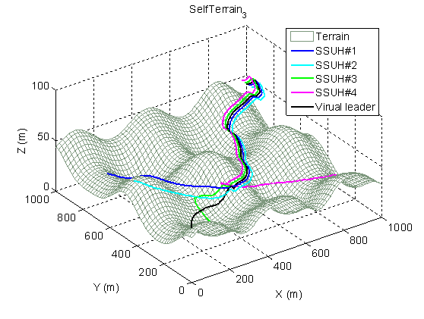
Abstract—This paper presents a cooperative formation control method using potential field (PF), particle swarm optimization (PSO) and real-coded genetic algorithm (RGA) for a team of small-scale unmanned helicopters (SSUHs). The cooperative formation control law using a virtual leader is proposed by an improved potential function, and the controller parameters are optimally searched by using the combination of PSO and RGA algorithms, called PSO-RGA algorithm. The performance and merits of the proposed method is exemplified by conducting one simulation on a group of four small-scale unmanned helicopters cooperatively flying over environments with complicated terrain. These simulation results indicate that all the following helicopters not only exactly track their positions and headings given by the virtual leader, but also have good abilities to avoid collisions among helicopters and obstacle avoidance between helicopters and the complex terrain.
Virtual leader
Virtual trajectory
generation
PF forces
generation
Formation trajectory
generation
SSUH
control

SSUHs
Fig. 1. Overall formation control structure using PF and PSO-RGA.
PF parameters tuning by PSO-RGA
Fig. 2. Cooperative formation trajectories of the SSUHs.
Cooperative Formation Control of Small-Scale Unmanned Multi-Helicopters Using Potential Field and PSO-RGA
Ching-Chih Tsai*, Zen-Chung Wang**
Department of Electrical Engineering, National Chung Hsing University
Corresponding author email: cct@gmail.com

Introduction
Cooperative formation control problems for multi-vehicle, multi-robot, and multi-agent systems have been widely addressed by many researchers. Most of these control approaches have been designed using consensus algorithms since such control methods take the advantages of network flexibility, but few have been done using other approaches, such as 3D potential field [1]. Although the proposed method in [1] was shown to achieve satisfactory formation control performance for unmanned multi-helicopters in free space, the cooperative formation control problem in terrain-dependent environments remains unsolved for SSUHs. Hence, this paper is aimed to derive the cooperative formation control law of a group of SSUHs using potential field (PF) and PSO-RGA algorithm, and to verify the feasibility and effectiveness of the proposed control method via simulations. By comparing to other existing control methods, the presented contents are novel in proposing an effective and practical cooperative formation control law for a group of SSUHs in a complicated environment with static and dynamic obstacles.

Method and Results
Fig. 1 shows the overall formation control structure using PF and PSO-RGA for a multi-helicopter system with a virtual leader. In the system, the PF algorithm generates four kinds of forces including the force between the i^{th} SSUH and virtual leader, the forces among this group of SSUHs, the force to avoid collisions among these SSUHs, and the obstacle -avoidance force between the i^{th} SSUH and the terrain environment beneath. The PSO-RGA algorithm is used to search for the best parameters in the PF algorithm, in order to obtain the best formation trajectories for all the SSUHs cooperatively flying over complicated terrain. Since simultaneous tuning of the formation control parameters is difficult via a try-and-error rule, the PSO-RGA algorithm in [2] is utilized to reduce design time and effort, and even obtain improved formation control performance.
To verify the proposed method, we conduct one simulation including four SSUHs to fly together in a parallel moving formation structure. Fig. 2 depicts the successful cooperative formation trajectories of the four SSUHs, showing the merits of the proposed method.
Conclusions
The paper has presented a cooperative formation control method using potential field (PF) and the PSO-RGA algorithm for a group of small-scale unmanned helicopters (SSUHs). Through computer simulation, the proposed method has been shown effective in cooperative formation control of a multi-helicopter system.
References
[1] T. Paul, T. R. Krogstad, and J. T. Gravdah, “UAV Formation Control Using 3D potential Field,” in Proc. of 16th Mediterranean Conference on Control and Automation Congress Centre, Ajaccio, France,,pp. 1240-1245, June 25-27, 2008.
[2] C. C. Tsai, K. I. Tsai, S. C. Hsu, S. S. Su, “Two-Loop PID Control Using PSO-RGA Algorithm for Solar Heat Pumps,” Proc. of 2014 International Conference on Machine Learning and Cybernetics, Lanzhou, China, 13-16 July, 2014.

 This work is financially supported in part by the Ministry of Science and Technology, Taiwan, R.O.C., under Grant MOST 103-2221-E-005-095-. Ching-Chih Tsai and Zen-Chung Wang are with the Electrical Engineering Department, National Chung-Hsiang University, e-mail: cctsai@nchu.edu.tw, and zenchung1125@gmail.com.

